**English 2C Unit 4 - Parties & Celebrations**

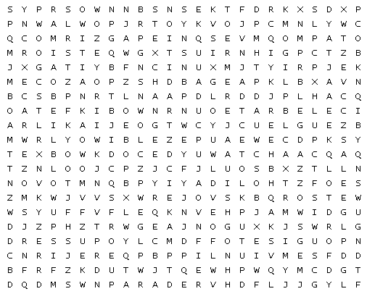

|  |  |  |  |  |  |
| --- | --- | --- | --- | --- | --- |
| BALLOONS |  | BLOW UP |  | BONFIRE |  |
| CELEBRATE |  | CELEBRATIONS |  | CLOWNS |  |
| DECORATIONS |  | DRESS UP |  | EVENT |  |
| EXCHANGE |  | FIREWORKS |  | HOLIDAY |  |
| LANTERN |  | MAKE |  | OCCASION |  |
| PARADE |  | PARTY |  | PUT UP |  |
| SEND |  | SET OFF |  | STAY UP |  |
| TRADITION |  | VISIT |  | WATCH |  |

English 2C U4 Parties&Celebrations AjarnGlen

http://puzzlemaker.discoveryeducation.com/WordSearchSetupForm.asp